December 4th , 2009
Volume 3 Issue 15
0

Upcoming Events
Dec. 18th:
*Hat Day for Riley Hospital
*Winter Party
*Last day before winter break
*Last day to donate a toy

Specials Update
Monday | Gym  
Tuesday | Library  
Wednesday | Music
Thursday | Art  
Friday | Alternates  art

Generosity at South Creek!
I sent home a flier on Thursday sharing with you that student council will be sponsoring IPS school 60. Many of the children at this school may not receive a Christmas gift this year due to the economy and socioeconomic status. We are trying to contribute a small gift for every student at this school. Many classrooms have already begun receiving donations to help in this effort! I know at this time of year it feels like everyone is requesting money and donations etc. Do not feel obligated. However, if you are able to donate a $5 gift to a child the same gender and age as your own, Awesome! You may just make a little ones Christmas a little merrier! Thank you for all that you already do! As always, you are what makes South Creek so great!

<e



Upcoming Activities
Language
Sight Words: I, am, the, little, to, a,
have, is, we, my, like, he, for, me, with,
she, see, look
Challenge words: can, go, and
Letter Recognition: Aa-Zz
Sounds/m/,/t/,/a/,/s/,/p/, c-/k/, /i/, /n/, /b/, /r/, /d/
Amazing Words: twins, newborn, crawl, walk, children,
babies
Reading 3.3
See How We Grow
Dan Did It!
At Bat
I Can Do Lots of Stuff!
Math:
We began Chapter 12: Numbers and Patterns
to 100 today! Chapter 6 test coming home next week.
Writers’ Workshop
We are discussing the inside story. This is when the author
includes thinking and feelings in their writing: what is happening on the inside, not just what is happening on the outside.
Social Studies: We are discussing upcoming holidays and how different
cultures –belief systems celebrate different holidays or the same holiday in different ways.
Character Education Program at South Creek
Many of you that have older children know that South Creek has an awesome character education program. Each adult in our building reminds our children to use their Gator GREATS. GREATS stand for Generosity, Respect, Effort, Attitude, Trustworthiness, and Self-Control. Each month I pick a gator in my room that exhibits and encourages others to use that trait.
In October, I chose a gator that showed generosity. Nariah was the recipient of the generosity award. In November, Myles was the recipient of the respect reward. In December, I look for a gator that exhibits effort.
Congratulations to these gators! Keep up the good work!
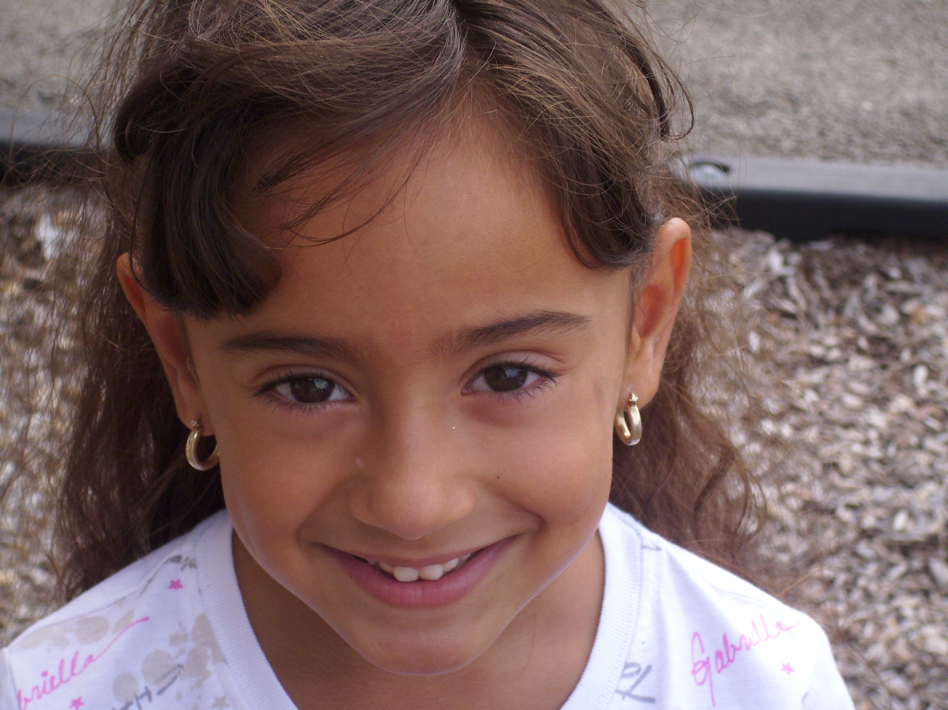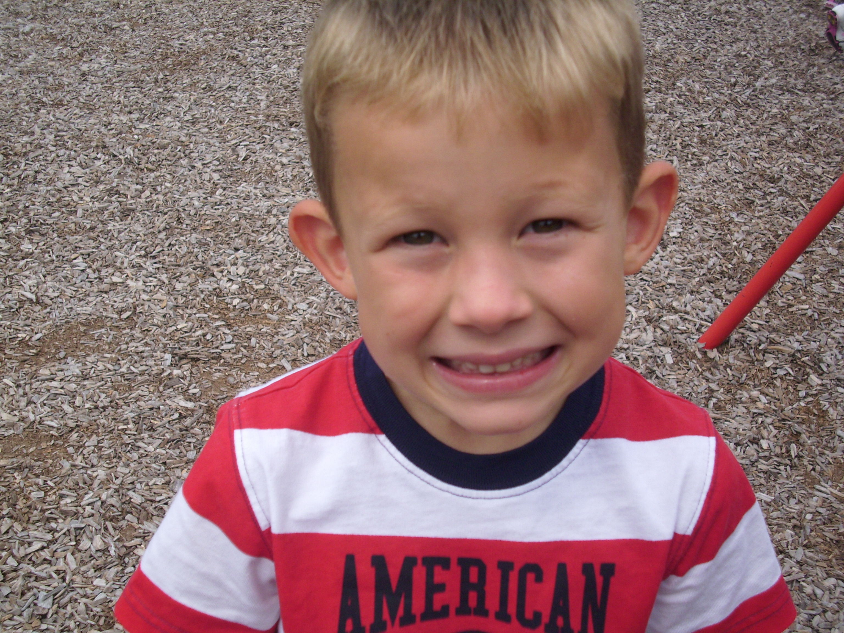
Generous! Respectful!

Homework
Reading Homework is due on December 8th. Please work on Sight word fluency and sounds.


Melissa Morris
Melissa.morris@ftcsc.k12.in.us
860-4735
www.melissamorriskindergarten.weebly.com

Mrs. Morris’s Newsletter

Star Students
Week of September 23
AM Jessica Archer
PM Reece Compton

